Degree of Protection IP WATER Test
Testing Laboratory (Name and Address of Laboratory): | Select...
Test Report No.:
Customer Information (Name/Position/Email): | Select...
Laboratory Technician (Name/Position/Email): | Select...
Test Report Date (YYYY-MM-DD): | Select date
Test Description: | Degree of protection against ingress of water (IP code)
Test Method: | According to Subclause 9.9.2 of IEC 62208
Applicable Standards: | EN 62208:2023 / IEC 62208:2023 / UNE-EN 62208=2012_VC=2016- EN 60529:1992 + A2:2013 / IEC 60529:1989_A2:2013_COR1=2019 / UNE-EN 60529:2018_A2:2018_AC:2019
Authorized Signatory (Name, Position, Date, Signature):
All testing is carried out in compliance with the requirements and specifications detailed in this report, and the results apply to the specimen tested. Opinions and interpretations are not given by Schneider Electric Laboratory. Testing was carried out on this test specimen only and provides no verification for the performance of other items in the same batch, or production run.

Test Samples Identification:
Three samples of the complete equipment or three test specimens of the part thereof shall be subjected to this test.
Project:

Description:
Reference:

Sample dimensions (mm) (H x W x D)

Family product: | Select family product
Mounting type: | Select type
Date of Receipt: (YYYY-MM-DD) | Select date
Traceability: | Select date
Numbers of samples to be tested: | Elija un elemento.

IP Degree Tested
IP Protection Degree tested :
Select IP Degree
Degree of protection against ingress of water (IP code) -

Enclosure Dimensions (mm) |  |  | Surface | Total Test Time
Height | Width | Depth | m²
1000 | 1000 | 1000 | 6,00 | 6 min 00 s

Enclosure dimensions:

Time divided by faces of the enclosure:
Face | m² | Seconds | Minutes
Front | 1,0 | 60 | 1 min 00 s
Rear | 1,0 | 60 | 1 min 00 s
Left side | 1,0 | 60 | 1 min 00 s
Right side | 1,0 | 60 | 1 min 00 s
Up side | 1,0 | 60 | 1 min 00 s
Down side | 1,0 | 60 | 1 min 00 s
Total | 6,0 | 360 | 6 min 00 s

Verdicts:
Test case does not apply the test object NA
Test case does meet the requirement P (Pass)
The object does not meet the requirement F (Fail)
The results are not determining ND/R

Environmental Conditions:
 | Required | Tested
Temperature: (°C) | 10 – 40 ºC
Relative Humidity: (%) | 25 % to 75 % RH
Atmospheric Pressure (mbar) | 860 to 1060 mbar

Test Equipment:
-
-

-

Preliminary Checks
-
-
-

Test Execution:
-
-

-
-
-
-

Observations:

Conclusion:
Summary of Findings: (Brief summary)

Statement of Conformity (based on results)

Revision History:
REV. | Reason for change, section updated | Approved by | Date (YYYY-MM-DD)
1 | Initial Release | Choose approver | Select date
 |  | Choose approver | Select date
 |  | Choose approver | Select date
 |  | Choose approver | Select date

ANNEX 1
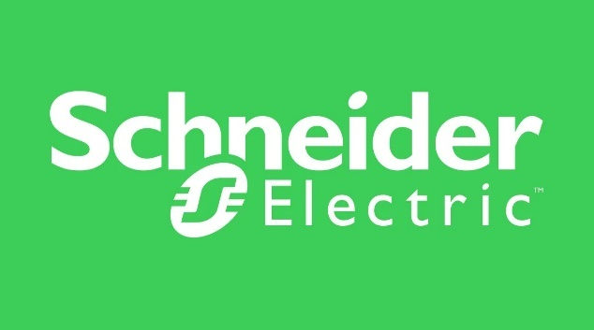



END OF THE REPORT

